This is a new series on Unity scripting tutorial. So in this series we will learn how to write scripts for unity from complete ground up. If you don't have any kind of previous programming experience, you are most welcome. And if you have previous programming experience and you want to brush up your skills in unity, you are most welcome to do so in this series. But start from complete ground up and we will build on that knowledge to know more about unity scripting.

So first of all, let Teacher explain why do we need scripting and what is scripting? OK, so if you have done any kind of programming codes before or if you have heard about computer programming, you know that computer programming basically means is giving instructions to the computer to do something. Now in case of unity, the same the same principle applies. So as an example, if we have a game, we want each and every object of the game to be interactive. We want to control each and every object. And we also want those objects to have their own properties so that they can do something. As an example, suppose I have a player and I want the player to move whenever I press the left and right keys (who knows) so we can write a script and attach that script to the player and inside the script I can write some instructions which will instruct the player to move left whenever

I press the left key and move right whenever right key is pressed. and we can write more instructions like I, it will shoot a bullet whenever we place I press the mouse arrow mouse left button(who knows). So as you can see, this is how we are actually giving some instructions to different game objects to do some tasks.

2:04

So this is what script does by using scripting we will give instructions to various game objects and we will make them operate as we want. We will make them operate according to our wish. So we will make them instantiate( maybe create dynamically ) whenever we want. We will destroy them whenever we want. We will move them, rotate them and whatever we want, do whatever we want. So this can be achieved by using scripting. So scripting is very, very useful for game development. So if you want to be a game developer, you have to be very confident and very professional or not pretty expert(who knows not clear) but you have to have good knowledge about scripting. OK, so now in the context of unity, Unity supports three different programming languages for scripting. That are

C # ,JavaScript and Bool. Now, Boo is not actually used a lot, so here are mainly two programming languages, C, Sharp and JavaScript. Now in this series of videos, we will use C sharp, and there are a couple of reasons behind that. So C Sharp was a language created by Microsoft for its dot net platform from C, Sharp is a complete object oriented programming language(Here the Teacher is wrong (According to ChatGPT)). So using it we can get a very organized way to write our scripts.

OK, if we use JavaScript we don't have any class there (In **JavaScript**, unlike in languages like Java or C#, you can **create objects without using classes**.(research later)) So and moreover, whenever we declare the type of a variable in some JavaScript, we don't have to write any type. So later on when you are reading your own scripts or when you were reading someone else's script, it will be a lot of problem because you will get into a lot of confusions. But if you're using C sharp, it has a more organized way to write code. You write all of your code inside a class. Inside that class you play some functions and variables, and before writing the variable names, you have to declare the types of those variables. So this is a very organized way to write code. So if you're starting scripting, if you're starting to learn unity and if you're starting to learn scripting, Teacher would recommend you to start with the C# because it has more organized way, as Teacher have said before. And if you apply for a job in any kind of game development or with unity, you will see that most of the gaming studios who uses the entity uses C Sharp as their programming and if you have watched some of the unity’s official video tutorials you will know that they also use C Sharp as the language for their tutorials

because they know that using C sharp is a better option than Javascript. So that’s why they use C# that’s why you should also use C# .OK, so that little introduction to programming, scripting and C Sharp. Let us try to create our very first script. So in Unity, there are a couple of options to create a script.

So we go to Project panel and click on create menu and then in submenu we have two option that is of Javascript or C# sharp in older unity( I think javascript is not used anymore so now it don’t have option of javascript) but now in modern Unity we click on + button in project as marked below

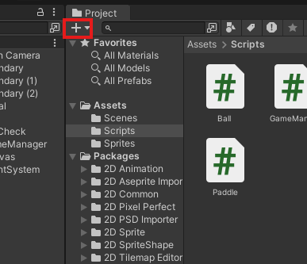

Click on it and then click on C# Script and now a C# script is made inside the selected folder our assets folder was selected so a new script file is created under assets folder as marked below

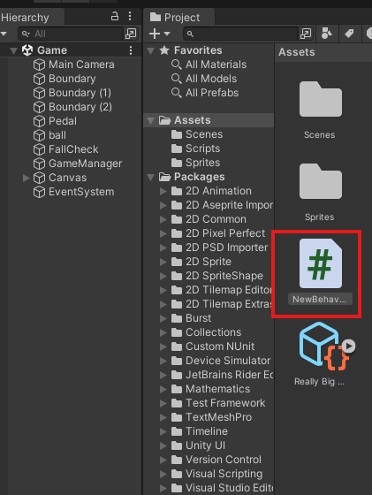

We can change its name by renaming it we name it “testScripts”. Okay, so this is one way to create a script. Another way to create a script is we can right click on the empty area of the minipanel(as marked below) of the project panel showing the inside of folder currently opened in project panel or the folder you have selected inside the project panel

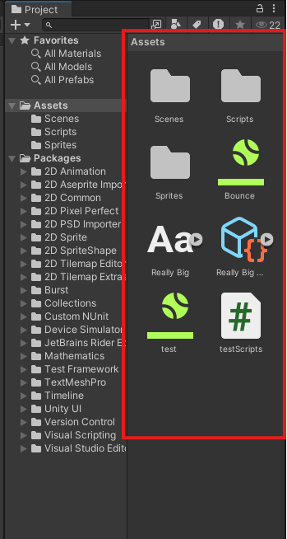

And then a submenu will open and then we go to create and then again another submenu will be shown click on C# script and a new script file is created inside that folder which was opened in minipanel of project panel.

6:32

Another way to do it is that is whenever we have any object in our game suppose we create an empty object here we click this object on Heirarchy and then in Inspector panel we click on add component to add a component to the empty object

Now in submenu we have option that is script and new script If we click on scripts, then it will allow us to add existing scripts that we have created before to this empty object or any object . And we can also create a new script and attach it to the same object at the same time so we can, we name it new script And whenever you are selecting, creating this new script, you can see that here we have two options(not in modern as there is only one language is used here that is C# (maybe) but in older there was two option that is C# and Javascript).Now you click on create and Add you can see that this script has been created. And added as component to the Empty object as marked below

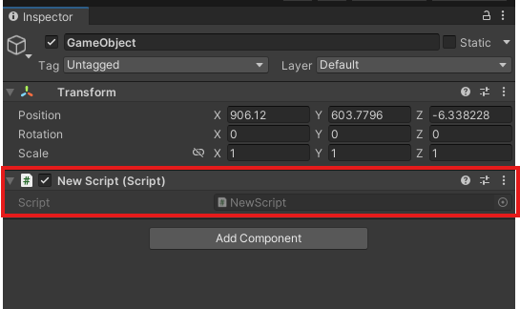

So this is how you create your very first script. And if you want to edit this unity has its inbuilt editor called the VSCode and if you want to open the script in VSCode, just double click on this script here or double click on the marked below

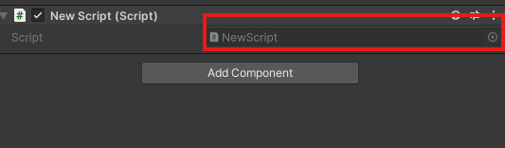

Now you can see our script look like below

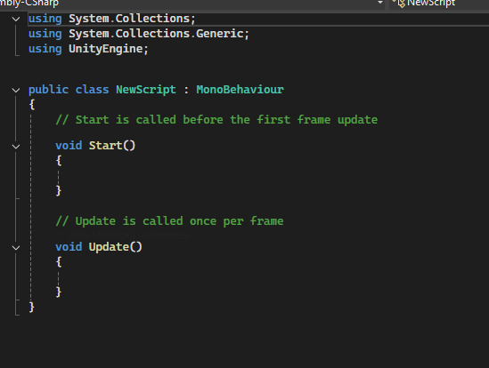

So whenever you create a new script it looks like above. So we will learn what these things mean in the next lesson. In this lesson we have learn about the basic scripting or what is scripting And we have also learned how to create and add new scripts to our game. And we have also learned how to open it in VSCode Look, In the next lesson, we'll learn what these things mean written in our code and we'll learn the very basics of scripting. See you in the next lesson.